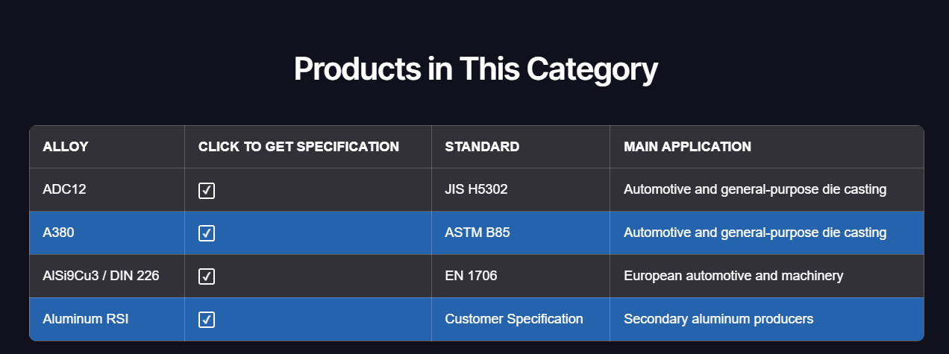
Please add between AlSi9Cu3 and Aluminum RSI
356 / Al-Si-Mg ASTM 356 and ✓

